## **How to Retarget Your Mocap Animations to MetaHuman in Unreal Engine 5**

This guide explains how to use the **Retargeting Kit** provided with your mocap animation(s) to convert and use them with MetaHuman characters inside Unreal Engine 5.

After using Mimem, you’ll receive animations in FBX format. These files are rigged to a shared mocap skeleton, and with our included **Retargeting Kit**, you can easily convert those animations for use with MetaHuman characters in UE5. Here’s a step-by-step walkthrough to get you up and running quickly.

### **1. Add the Retargeting Kit to Your Project**

Before opening Unreal, make sure you:

* Copy the entire RetargetingKit folder into your UE5 project’s Content/ folder.
* Launch your Unreal Engine project (version 5.3 or higher recommended).

This kit contains everything needed: the IK Rig, the Retargeter, and the correct mocap skeleton (Mimem_Skeleton).

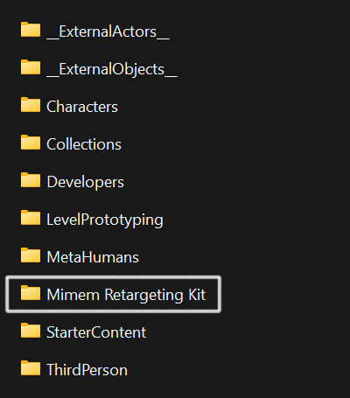

### **2. Set Up Folders for Organization**

To keep things tidy:

* Create a folder for your **raw mocap animations** — e.g. Content/Animations/Mocap/
* Create another for the **retargeted MetaHuman animations** — e.g. Content/Animations/MetaHuman/

This helps avoid confusion between source files and ones that have been retargeted for your Metahuman.

### **3. Import Your Animation Files**

You’ll now bring in your FBX animations:

* In UE5, right-click your Mocap folder and choose Import to...
* When prompted:  
  + Set **Skeleton** to Mimem_Skeleton (very important!)
  + Uncheck "Import Mesh" if the FBX includes a model
* Complete the import

🟡 Tip: All animations must use this same skeleton to be compatible with the retargeting setup.

### **4. Open the Retargeter Tool**

Navigate to:

Content/Retargeter/MimemToMetaHuman

Open this asset. This is a preconfigured **IK Retargeter** that’s been set up to map your mocap animations correctly onto MetaHuman characters.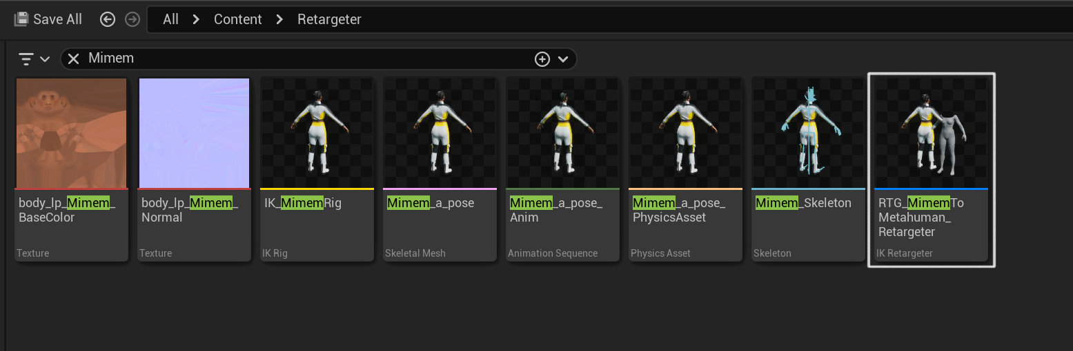

### **5. Retarget and Export Animations**

Once you're inside the retargeter:

1. On the right, switch to the **Asset Browser** tab.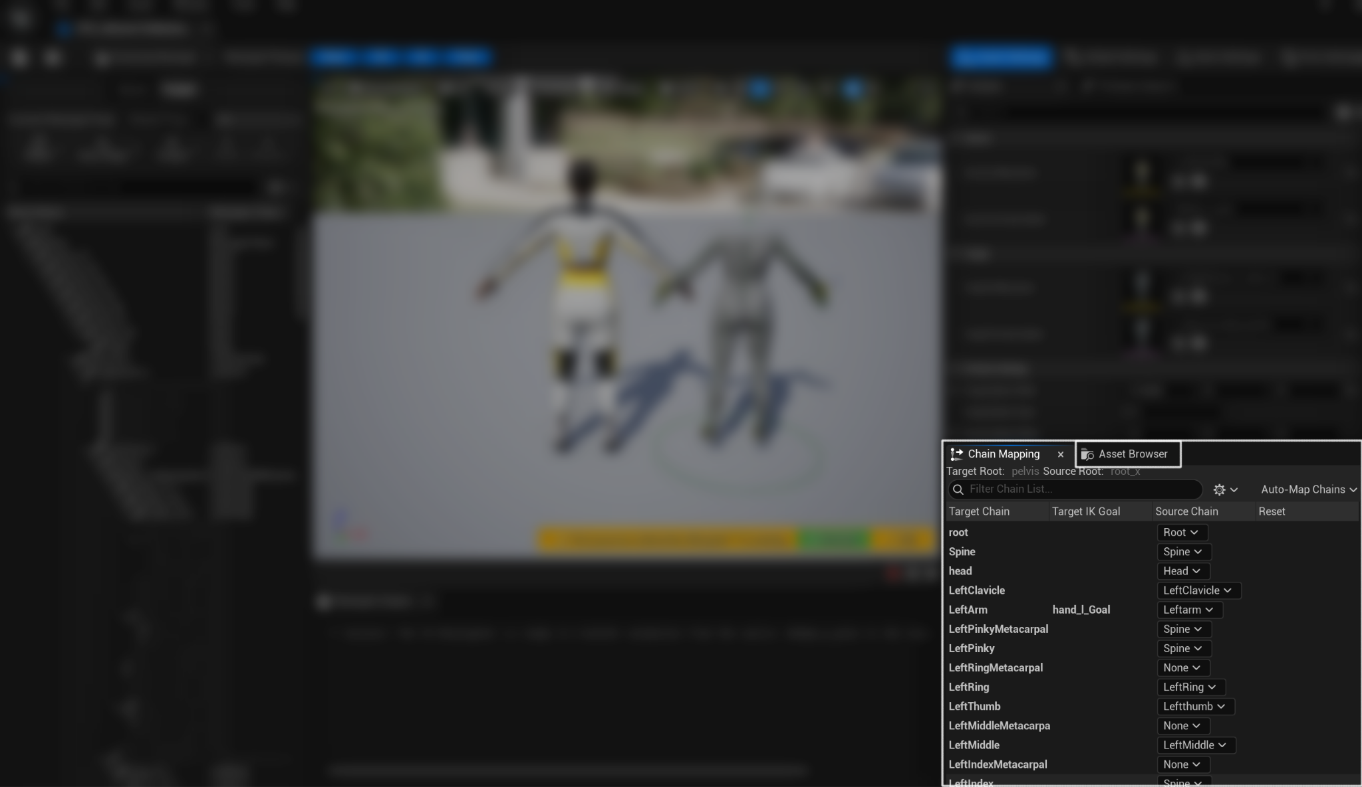
2. You’ll see a list of all mocap animations using the correct skeleton.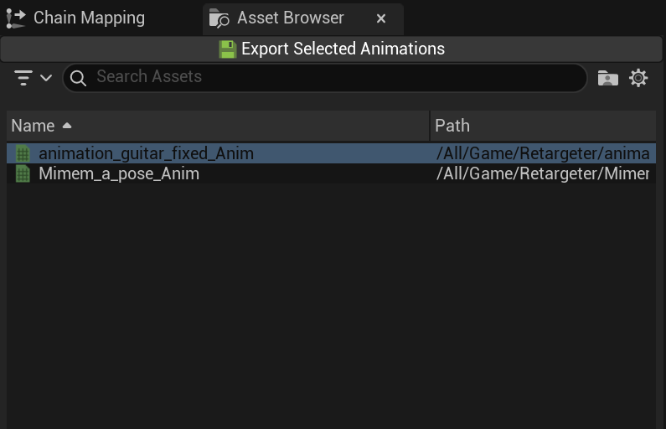
3. Select the one you want to convert.
4. Click the **Export Selected Animations** button.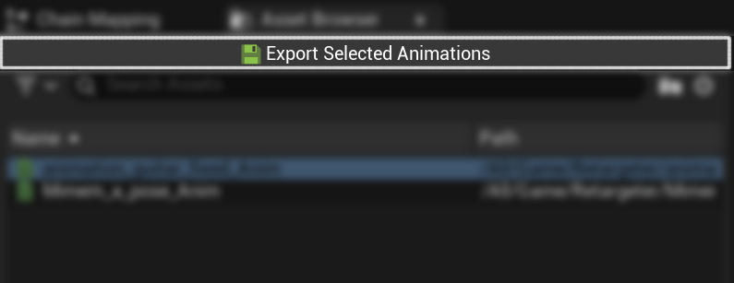

Then:

* Choose a **name prefix or suffix** (e.g. MH_, Converted_, etc.) to help you distinguish the new version from the initial animation.
* Select your MetaHuman animation folder as the export location. 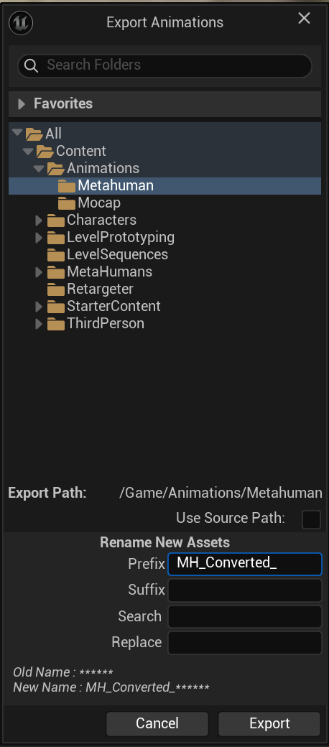

Hit export and Unreal will generate a brand-new animation that works on MetaHuman characters.

### **6. Use Your New MetaHuman Animation**

The converted animation is now available inside your export folder. You can:

* Preview it on any MetaHuman in the editor
* Use it in Sequencer for cinematics
* Add it to animation blueprints for gameplay

### **Troubleshooting & Tips**

* **Animation not showing in the Retargeter?** Make sure it was imported using Mimem_Skeleton. If it wasn’t, Unreal won’t recognize it as compatible.
* **Can I reuse this setup in another project?** Yes! Just copy the RetargetingKit folder into the Content folder of your next project.
* **Do I have to do this every time?** No. Once the kit is in place and animations are imported using the same skeleton, you can quickly retarget new files in just a few clicks.